* **Program to print "Hello World".**

class Hello

{

public static void main(String args[])

{

System.out.println("Hello World");

}

}

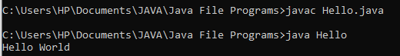

* **Program to take numbers using Scanner class.**

import java.util.Scanner;

class Num

{

public static void main(String args[])

{

Scanner sc= new Scanner(System.in);

System.out.println("Enter the first number: ");

int a = sc.nextInt();

System.out.println("Enter the second number: ");

int b = sc.nextInt();

System.out.println("2 entered numebrs: " + a + " " + b);

}

}

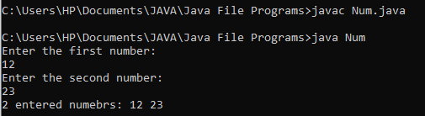

* **Take 2 inputs and add them using cmdline arguments.**

class Add

{

public static void main(String args[])

{

int a = Integer.parseInt(args[0]);

int b = Integer.parseInt(args[1]);

System.out.println("Addition: " + (a+b));

}

}

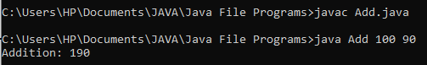

* **Calculate volume and CSA of a cone.**

class Volume

{

public static void main(String args[])

{

final double PI = (double)3.14;

double r = Double.parseDouble(args[0]);

double h = Double.parseDouble(args[1]);

double l = Double.parseDouble(args[2]);

double volume = (PI*r*r*h)/3;

double csa = PI*r*l;

System.out.println("Volume of cone: " + volume);

System.out.println("CSA of cone: " + csa);

}

}

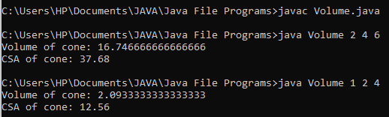

* **Area of triangle.**

class triangle

{

public static void main(String args[])

{

double b = Double.parseDouble(args[0]);

double h = Double.parseDouble(args[1]);

final double PI = (double)3.14;

double area = (b*h)/2;

System.out.println("Area of triangle: " + area);

}

}

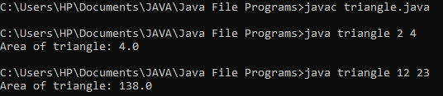

* **Vote Eligibility Program.**

import java.util.Scanner;

class vote

{

public static void main(String args[]) {

Scanner sc = new Scanner(System.in);

System.out.println("Enter the Age: ");

int age = sc.nextInt();

if (age >= 18)

System.out.println("Eligible");

else

System.out.println("Note Eligible");

}

}

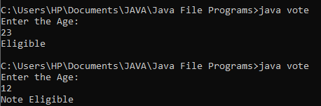

* **Leap Year Program.**

import java.util.Scanner;

class LeapYear {

public static void main(String args[]) {

Scanner sc = new Scanner(System.in);

System.out.println("Enter the Year: ");

int year = sc.nextInt();

if((year % 400 == 0) || (year % 4 == 0 && (year % 100 !=0)))

System.out.println(year + " is a Leap Year.");

else

System.out.println(year + " is not a Leap year.");

}

}

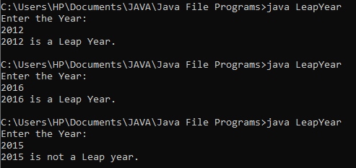

* **Leap Year Program.**

class Prime {

public static void main(String args[]) {

int a = Integer.parseInt(args[0]);

boolean flag=false;

for (int i = 2; i <= a/2; ++i) {

if(a % i == 0)

{

flag=true;

break;

}

}

if(!flag)

System.out.println(a + " is prime number.");

else

System.out.println(a + " is not a prime number.");

}

}

